Id | Can`t read text on dropdown menu
3 | Steps to reproduse:  - Open https://pkrv.dp.gov.ua/  - Place the cursor on dropdown menu „Публiчна iнформацiя“  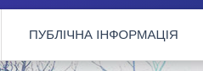  3. Choose „Доступ до публічної інформації“  Expected result:  Dropdown menu is fully visible on the screen  Actual result:  Dropdown menu is overlapped  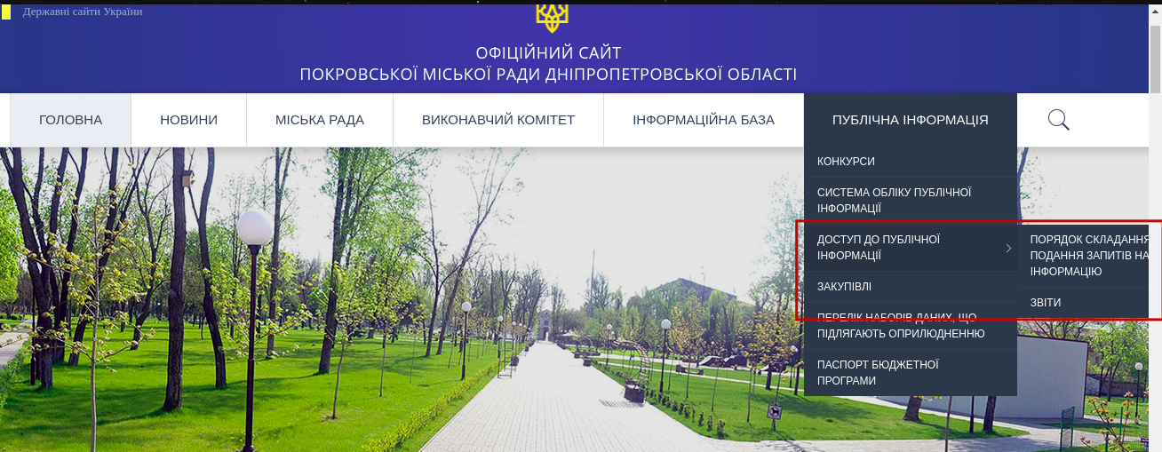  Browser use:  - Google Chrome for Ubuntu 90.0.4430.72 official 64-bit  - Mozila Firefox for buntu 86.0 64-bit  - Opera for Ubuntu Core 18 (x86_64; GNOME) 74.0.3911.160  OS use :  Ubuntu 20.04.2 LTS  Gnome 3.36.8

